William Adoukonou

[Company name]  [Company address]

COmputer Networks and communication assignment 1

# Contents

Contents 1

Introduction 3

Task 1 – Network Mapping Technologies 4

Physical Issues in a Network 6

Issues in the TCP/IP and OSI Model 7

Data Link layer 7

Network Layer 7

Transport Layer 7

Session Layer 7

Presentation Layer 7

Application Layer 7

Interconnect opportunities and challenges 8

Data 8

Routing Protocols 8

Traffic Management 8

Latency 8

Congestion 9

Configuration 9

Network Expansion Issues 9

Multi Network Integration 10

Network Evolution 10

Network Revolution 10

Network Using Cisco Packet Tracer 11

IP Addresses and Subnet Masks 11

Cabling and transition methods 13

Ping Testing 13

Extension Plan 14

Design Choices 14

Conclusion 15

Reference List 16

# Introduction

This assignment starts of by covering the different network mapping technologies (DataDog, Cisco Packet Tracer) and what they offer.

It then details the physical (hardware damage etc.), software (TCP/IP) and interconnection issues that can appear in a network. It then describes how traffic is managed and what problems can occur.

The next task outlines the various obstacles Network Managers can encounter when expanding their networks. The last part then uses one of the mapping technologies (Cisco Packet Tracer) to demonstrate how a network can be virtually designed and evaluated.

# Task 1 – Network Mapping Technologies

Network mapping is a way to describe the physical connections between various systems/computers in a network *(study.com, 2023)*. It acts as a visual representation of how the devices will interlink. There are many versions of presenting this, but the leading technologies include:

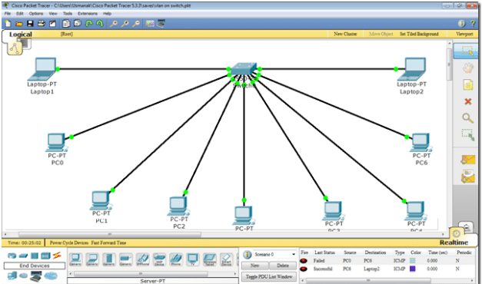Cisco Packet Tracer (CPT) - A software that allows users to "create network topologies and imitate modern computer networks." *(Wikipedia, 2023)*. useful for anyone since you can learn about the components required for a network.

*(Figure 1, Image of computers connected to switch on CPT, itprc.com, 2023)*

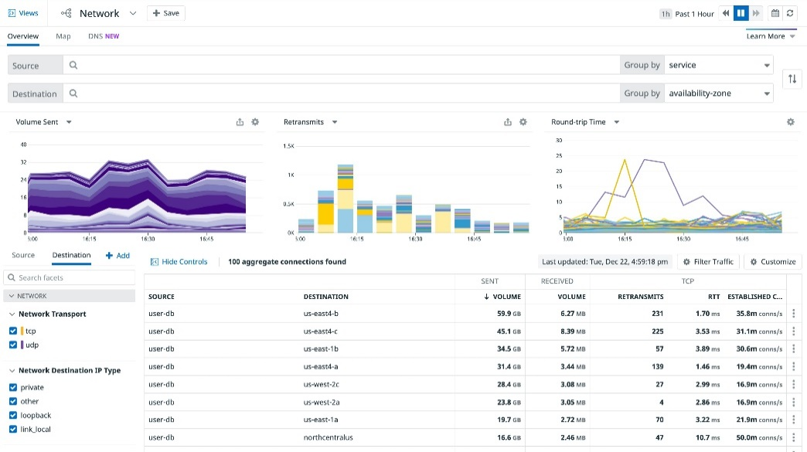Datadog - A monitoring tool that can be used to analyze the performance of the user's network. Datadog is more focused on the statistical performance of the network.

*(Figure 2, DNS performance of a network using datadog, datadoghq.com, 2023)*.

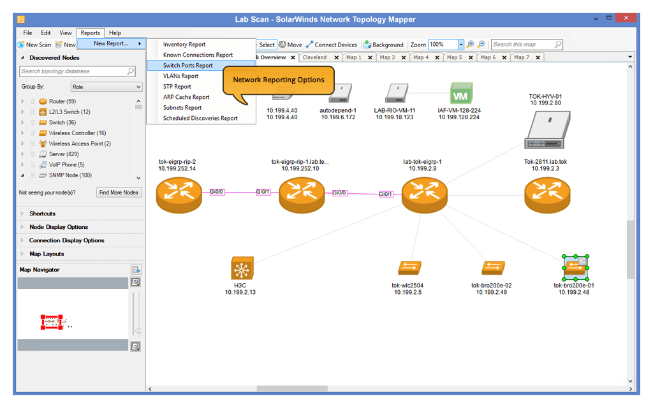SolarWinds Network Topology Mapper - SolarWinds allows you to visualize your network topology. A topology is the layout your network is designed in. IT experts, and other "professionals who need to manage and optimize their networks may find this beneficial." *(solarwinds.com, 2023)*

*(Figure 3, network mapped out using SolarWinds, solarwinds.com, 2023)*

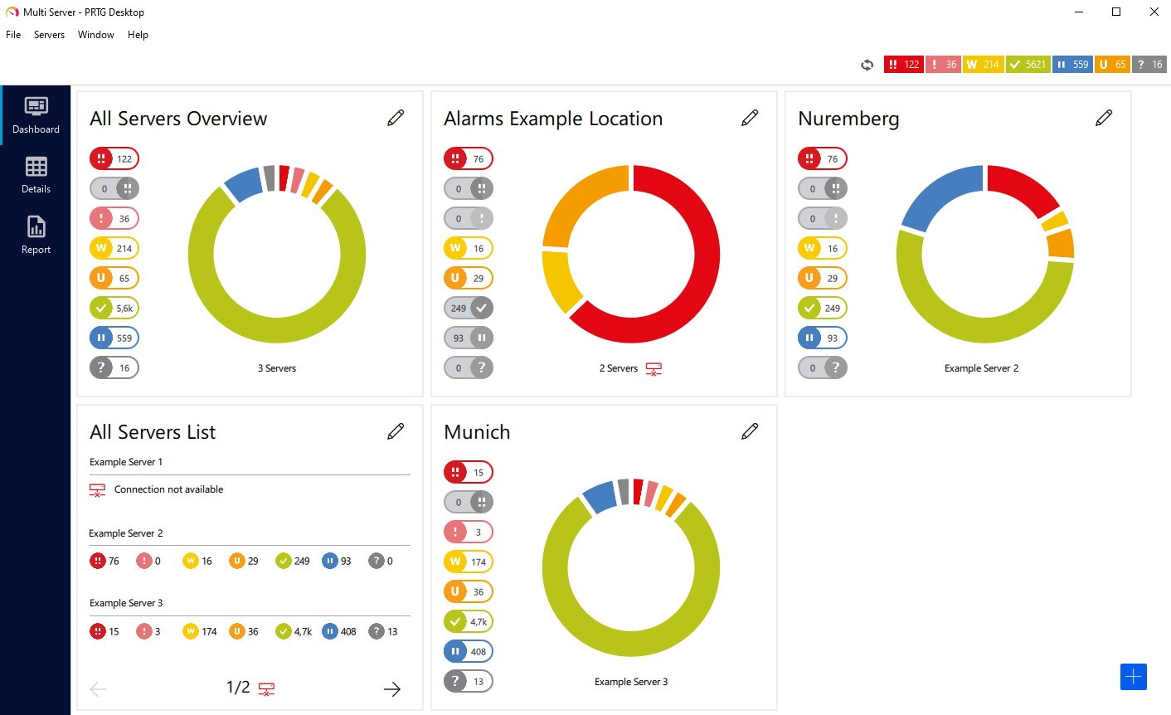Paessler PRTG Network Monitor - a network monitoring solution that allows consumers to track their network devices, servers, VMs (virtual machines), and more in real-time.

*(Figure 4, custom dashboard monitoring multiple networks using PRTG. Paessler.com, 2023)*.

ManageEngine- ManageEngine has a user-friendly and customizable interface. that assists enterprises in monitoring and managing their IT infrastructure, improving service delivery, and ensuring security.

*(Figure 5, Network Outage monitored on ManageEngine. Getapp.co.uk, 2023)*.

# Physical Issues in a Network

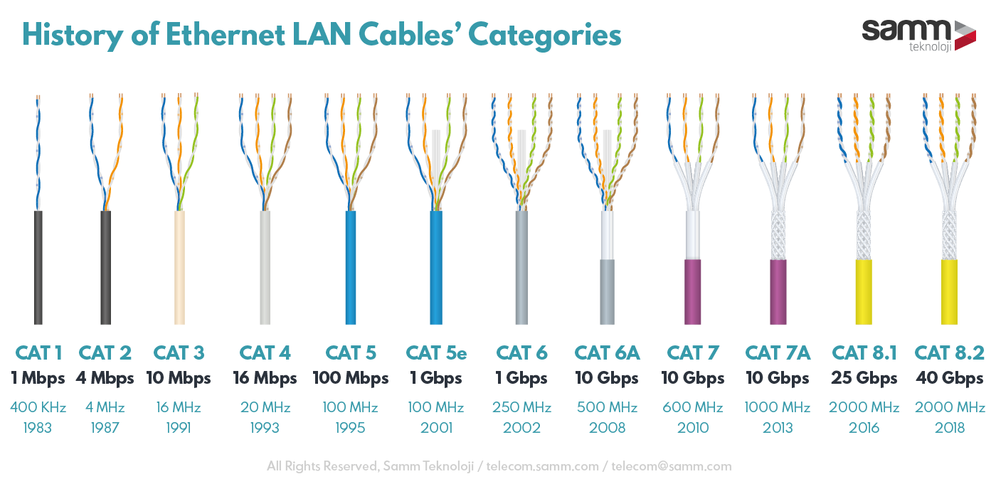When mapping a computer network, cable quality is the most important physical issue. An example is using a CAT4/5 ethernet cable over a CAT6/7 one. The cable length and transfer speed of the lower CAT cables are worse, causing your network to suffer. Here is a diagram describing the history of LAN cables.

*(Figure 6, telecom.samm.com, 2022)*

Another physical factor that can hinder your network is interference. Other electronic devices like radios can interfere with the signals. "Obstacles like walls or metal objects can also block wireless signals." *(eyenetworks.no, 2023).*

Physical security is also a severe issue that can occur in a network. “Leaving hardware unprotected make its more vulnerable to theft or damage.” *(tutorialspoint.com, 2023).* This is why it’s important to leave any devices like switches and routers in a secured environment however this isn’t always possible. One common example of this is powerlines. During bad weather they can be overvolted.

*(Figure 7, schukat.com, 2023)*

# Issues in the TCP/IP and OSI Model

The Transmission Control Protocol/Internet Protocol (TCP-IP) and Open System Interconnection (OSI) models both demonstrate how each component of a network link together.

## Data Link layer

This is where the unstructured data is fixed and transformed into frames. This is achieved with components such as ethernet connections and switches. One of the main issues on the data link layer is the loss of frames. This can happen due to various reasons such as collisions, noise, or other errors in the transmission medium. (Protocols: ARP, CSLIP, ATM...)

## Network Layer

On this layer, the packets of data are now assigned addresses and routes. The “optimal route is also calculated here” *(csnewbs.com, 2023)*. Routing problems can arise due to factors such as incorrect configuration of routing cables. If routing problems are not resolved, data packets may not reach their destination or may experience significant delays. (Protocols: IPv4, IPv6…)

## Transport Layer

The transport layer takes the and breaks them down into ‘packets.’ They’re given numbers so the receiver can organize the data. Issues can occur if the packets are not sorted properly. The data would be sent in a scrambled order causing the message to arrive incorrectly. (Protocols: TCP, UDP, DCCP...)

## Session Layer

This layer is responsible for managing and coordinating communication sessions between two network devices. It’s where the “Session” is initiated. One potential issue that can arise on the session layer is session establishment. If the session establishment fails, the devices would be unable to communicate with each other. (Protocols: PPTP, SAP, L2TP...)

## Presentation Layer

The presentation layer can be thought of as the final product that the user gets to see. The data is displayed in “a standard format that other devices can understand.” *(csnewbs.com, 2023)*. It makes sense that an issue that is common on this layer is formatting errors. data is not properly formatted; it may be unreadable or incomprehensible to the receiving device. (Protocols: XDR, TLS, SSL…)

## Application Layer

using protocols such as DNS and HTTP, this layer deciphers messages into “a form that is understood by the sender and the recipient devices” *(bbcbitesize.co.uk, 2023).* Denial of Service attacks (DDoS) can occur here. This is when the user is flooded with traffic which causes their server to crash. (Protocols: HTTP, DHCP, FTP…)

# Interconnect opportunities and challenges

## Data

With the development of new technology, interconnectivity of data has more opportunities than ever. One use is for IoT (internet of things) devices. Devices like smart TVs generate vast amounts of data that can be used to improve processes and services. One drawback is the data’s security. “When data is being transmitted over the internet, it’s vulnerable to cyber-attacks.” *(wwt.com, 2022)*.

## Routing Protocols

When data is transferred between 2 routers, it uses one of the 2 routing protocols. The dynamic routing protocol allows the sending and receiving routers to send data to different destination routes and overall transfer efficiently. Static Routing is the opposite, as it does the same job but only allows the data to go through one pre-set destination route. Each has its benefits and drawbacks.

Dynamic Routing

+ Allows for data to be sent via multiple destination routes.

- offers less security since the route is shared across the whole network

Static Routing

+ offers more security since the route is kept hidden.

- algorithm must be manually changed if destination changes

# Traffic Management

## Latency

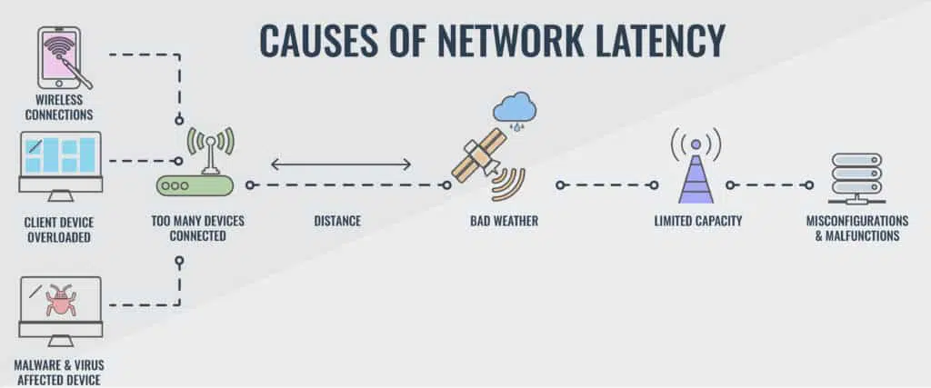Network latency describes the amount of time it takes for data to travel between two endpoints on a network. “It’s caused by factors such as distance and weather.” *(aws.com, 2023)*. High network latency can also cause increased response times, reduced data transfer rates and timeouts. It can also. lead to a poor user experience.

*(Figure 8, comparitech.com, 2023)*

## Congestion

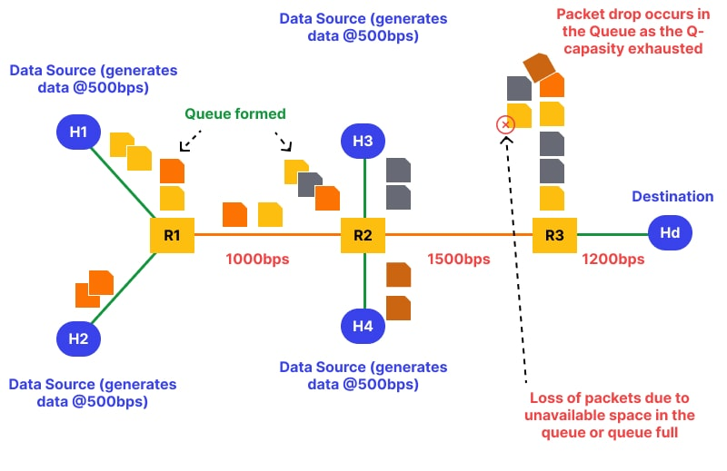When there’s more traffic on a network than it can handle, network congestion occurs. This leads to delays and packet loss. In common cases, users will experience slow page load times, call dropping, and video buffers. In extreme cases network congestion will even cause a network to shut down completely. To prevent this, network admins use techniques such as “Quality of service (QoS) policies, bandwidth throttling, and load balancing.” *(atera.com, 2021).*

*(Figure 9, diagram showing how network traffic forms, wallarm.com, 2022)*

## Configuration

Misconfiguration in networks applies to the incorrect/incomplete setup of network devices and protocols. Simply not connecting a network with the right cables can have a knock on effect and cause the other issues mentioned. This also leads to unexpected results or errors. To fix this, admins usually run error checks such as click redundancy checks (CRC), and error correction codes (ECC).

# Network Expansion Issues

When the performance of a network starts to decrease, companies will usually look to expand it. Connecting more devices which allows for smoother operations. In theory it’s simple to expand a network however there are issues that can arise. Some include:

Cost - Expanding a network can be expensive, “requiring investment in hardware, software, and personnel.” *(edisoncarriersolutions.com, 2023).*

Performance - as mentioned before poorly configured network devices can cause network performance issues. Furthermore, inadequate bandwidth and network congestion also contribute.

Security - With more devices and users on the network, there is a greater risk of unauthorized access, data breaches, and cyber-attacks.

## Multi Network Integration

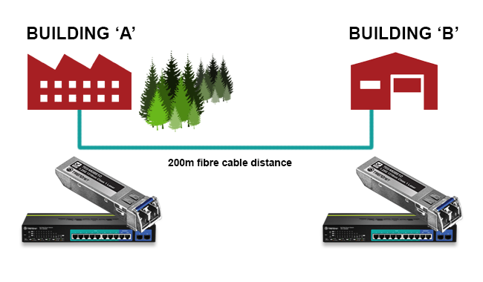Companies with multiple departments usually have their own separate networks. To interlink them, they use a technology called Network integration, “allowing them to communicate and exchange information.” *(globalspec.com, 2018)*. This lets the company benefit from the efficiency that comes with multi-network power however there are drawbacks. This process can completely fail if both networks aren’t compatible in the 1st place.

*(Figure 10, two buildings with integrated networks, broadbandbuyer.com, 2023)*

## Network Evolution

When looking at networking technologies, they’ve evolved from previous, but their power ceiling has massively increased for example, Dial-Up to Broadband. “We used to use a phone line to connect to the internet” but now we use “high-speed data transmission technologies” like cable and fiber optic. *(plus.net, 2023)*

## Network Revolution

An example of network technology revolution is the introduction of 5G networking. These networks “offer faster speeds, lower latency, and massive device connectivity” *(ee.co.uk, 2021).*  This enables new technologies such as autonomous vehicles and remote healthcare.

# Network Using Cisco Packet Tracer

This is a standard layout for a computer network used in a school as requested. It features 30 computers all connected to 2 switches which are then connected to a router, allowing them access to the internet. The network also has a printer which is connected to the router which is essential for wireless printing.

## IP Addresses and Subnet Masks

For the computers to access the internet and communicate with each other, they need to be assigned Internet Protocol or IP addresses. An IP address is a unique numerical identifier assigned to devices for a computer network identification purpose when sending and receiving information. The standard format for an IP address on a network is 192.168.0.X. It’s convenient to only change the last digit for each machine which is what was done in the table of addresses below.

## Diagram Description automatically generatedCabling and transition methods

The systems in the diagram have been connected to the switch using copper straight-through cables. Cisco Packet Tracer allows the user to see that the connection is active by showing a green arrow. A copper straight-through cable is necessary for connecting two devices of the same type in a local area network and is designed specifically to allow for proper data transmission and reception between the devices. The transmission pins on each end of the cable are wired in the same order, allowing for the data to be transmitted and received properly between the two devices without the need for a crossover.

## Ping Testing

Ping testing machines in Cisco Packet Tracer are useful for several reasons.

Verifying connectivity: The ping command can be used to determine whether two devices on the network can interact with one another. This can aid in troubleshooting connectivity issues.

Ping tests can also be used to calculate the round-trip time (RTT) that packets take to transit between two devices. High RTT values could be a sign of packet loss, network congestion, or other problems that could harm the performance of the network.

This screenshot shows machine 15 being pinged to measure the latency of a response.

f

## Extension Plan

UCBs design for its computer system is outdated. The network can still run smoothly with an increased number of systems. In the extension plan, there’s extra computer systems connected to allow for bigger classes. The initial increase of 10 will be tested and evaluated before adding another 10. This is to measure the increase in bandwidth and stress test the network. These extra computers will feature 6 core CPU’s, 16GB RAM and SSDs, all connected by higher frequency cabling. This will also be trialed by UCB and if successful, should be implemented into all the systems.

## Design Choices

There are multiple reasons why the new systems have much better specs than UCBs original layout:

Improved Performance: *(telgroup.co.uk, 2022)* says the increased cores in the CPU allow for “more processes to be done at the same time, increasing productivity.” This works alongside the RAM upgrade since more temporary information can be stored at one point. The SSDs will also make a dramatic increase in file transfer speed. Students can run software and applications faster, providing better overall performance.

Increased Lifespan: High-spec machines like the ones in the diagram tend to have better build quality. making them “more durable and less prone to hardware failures.” *(edtechmagazine.com, 2021).* This can help schools save money in the long run by reducing the need for frequent replacements or repairs.

Better Security: The new UCB machines are more likely to have the latest security features and updates, which can help protect the school's network and data from cyber threats. Additionally, machines will be more resistant to malware and other malicious attacks, which can help prevent data breaches and other security incidents. Saving UCB lots in damages and system repairs.

*(Figure 11, modern computer lab, istock.com, 2023)*

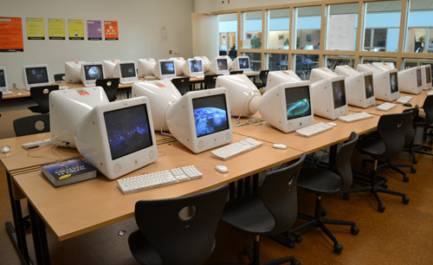

*(Figure 12, image of old computer lab. news.a2schools.org, 2023)*

# Conclusion

To Summarise, mapping technologies are used to create a virtual layout for a network. In these networks, there can be physical issues such as damage to the components as well as software issues when sending and receiving packets of data. This data can be routed using dynamic or static protocols which each provide their own benefits. One issue, however, lies in the traffic and how its managed. To combat poor traffic management, it advised to expand your computer network, but this also brings its own host of issues.

# Reference List

*study.com. 2023. No page title. [ONLINE] Available at: https://study.com/academy/lesson/network-mapping-the-attack-surface-definition-tools-types.html#:~:text=Network%20Mapping%20can%20be%20defined,of%20connections%20between%20systems%2Fcomputers.. [Accessed 16 February 2023].*

*Wikipedia. 2023. Packet Tracer - Wikipedia. [ONLINE] Available at: https://en.wikipedia.org/wiki/Packet_Tracer. [Accessed 23 February 2023].*

*Tim Keary. 2023. Ultimate Guide to Packet Tracer - ITPRC. [ONLINE] Available at: https://www.itprc.com/packet-tracers/. [Accessed 23 February 2023].*

*Datadog . 2023. Network Monitoring | Datadog. [ONLINE] Available at: https://www.datadoghq.com/product/network-monitoring/#:~:text=Network%20Performance%20Monitoring%20lets%20you,routers%2C%20firewalls%2C%20and%20switches.. [Accessed 23 February 2023].*

*Datadog . 2023. Network Monitoring | Datadog. [ONLINE] Available at: https://www.datadoghq.com/product/network-monitoring/. [Accessed 27 February 2023].*

*IT Management Software and Observability Platform. 2023. IT Management Software and Observability Platform | SolarWinds. [ONLINE] Available at: https://www.solarwinds.com/. [Accessed 27 February 2023].*

*Home. 2023. Discover the 3 Paessler PRTG monitoring solutions. [ONLINE] Available at: https://www.paessler.com/prtg?gclid=Cj0KCQiA6fafBhC1ARIsAIJjL8l_B0bntcuTG8F1Xbwkl1DXrWTzp6KhlcB1Bm-4XqTiVBYqwmgoDF8aAvLdEALw_wcB. [Accessed 28 February 2023].*

*PAESSLER. 2023. PRTG Desktop | PRTG Manual. [ONLINE] Available at: https://www.paessler.com/manuals/prtg/prtg_desktop. [Accessed 28 February 2023].*

*GetApp. 2023. ManageEngine OpManager Reviews, Prices & Ratings | GetApp UK 2023. [ONLINE] Available at: https://www.getapp.co.uk/software/90387/opmanager#media. [Accessed 02 March 2023].*

*Jorunn Danielsen Newth. 2023. 10 Things in Your Home that Interfere with and Block Wi-Fi Signals. [ONLINE] Available at: https://eyenetworks.no/en/10-things-that-disturb-and-block-wi-fi-signals/. [Accessed 02 March 2023].*

*What are the Physical Threats in Information Security . 2023. What are the Physical Threats in Information Security . [ONLINE] Available at: https://www.tutorialspoint.com/what-are-the-physical-threats-in-information-security#:~:text=Physical%20threat%20to%20a%20computer,fire%2C%20war%2C%20earthquakes%20etc.. [Accessed 09 March 2023].*

*https://telecom.samm.com/. 2023. Categories of Ethernet LAN Cables in History. [ONLINE] Available at: https://telecom.samm.com/history-of-ethernet-lan-cables-categories. [Accessed 09 March 2023].*

*Schukat electronic. 2023. Protect switching power supplies against voltage surges. [ONLINE] Available at: https://www.schukat.com/schukat/schukat_cms_en.nsf/index/CMSCC86AC294CFC0E6BC12583D20039B9C6?OpenDocument. [Accessed 09 March 2023].*

*BBC Bitesize. 2023. Network layering - Networks - Edexcel - GCSE Computer Science Revision - Edexcel - BBC Bitesize. [ONLINE] Available at: https://www.bbc.co.uk/bitesize/guides/zj88jty/revision/7. [Accessed 16 February 2023].*

*CSNewbs. 2023. 3.6 - 7 Layer OSI Model - Eduqas GCSE (2020 spec) | CSNewbs. [ONLINE] Available at: https://www.csnewbs.com/eduqas2020-3-6-7layerosimodel. [Accessed 16 March 2023].*

*CSNewbs. 2023. 3.6 - 7 Layer OSI Model - Eduqas GCSE (2020 spec) | CSNewbs. [ONLINE] Available at: https://www.csnewbs.com/eduqas2020-3-6-7layerosimodel. [Accessed 16 March 2023].*

*What is Data Interconnection and Why Do You Need It? - WWT. [ONLINE] Available at: https://www.wwt.com/article/what-is-data-interconnection-and-why-do-you-need-it. [Accessed 16 March 2023].*

*Amazon Web Services, Inc.. 2023. What is Latency? - Network Latency Explained - AWS. [ONLINE] Available at: https://aws.amazon.com/what-is/latency/#:~:text=Network%20latency%20is%20the%20delay,response%20times%20have%20low%20latency.. [Accessed 19 March 2023].*

*Stephen Cooper. 2023. 12 Best Network Latency Testing Tools for 2023 & Test Guide. [ONLINE] Available at: https://www.comparitech.com/net-admin/network-latency-testing-tools/. [Accessed 19 March 2023].*

*Doron Ben Cohen. 2023. How to Reduce Network Congestion | Atera's Blog. [ONLINE] Available at: https://www.atera.com/blog/how-to-prevent-and-reduce-network-congestion/. [Accessed 19 March 2023].*

*What is congestion in networking? How to fix it?. 2023. What is congestion in networking? How to fix it?. [ONLINE] Available at: https://www.wallarm.com/what/what-is-congestion-in-networking. [Accessed 19 March 2023].*

*Edison. 2023. How to Overcome Common Enterprise Network Challenges. [ONLINE] Available at: https://www.edisoncarriersolutions.com/blog/how-to-overcome-common-enterprise-network-challenges. [Accessed 30 March 2023].*

*Globalspec.com. (2018). Engineering360 - Engineering Search & Industrial Supplier Catalogs. [online] Available at: https://www.globalspec.com/.*

*www.broadbandbuyer.com. (n.d.). How to network two buildings using fibre. [online] Available at: https://www.broadbandbuyer.com/features/3305-how-to-network-two-buildings-using-fibre/.*

*EE. 2023. EE's 5G Network & Internet | What is 5G? | EE. [ONLINE] Available at: https://ee.co.uk/why-ee/5g-on-ee#5g. [Accessed 12 April 2023].*

*study.com. 2023. No page title. [ONLINE] Available at: https://study.com/academy/lesson/network-mapping-the-attack-surface-definition-tools-types.html#:~:text=Network%20Mapping%20can%20be%20defined,of%20connections%20between%20systems%2Fcomputers. [Accessed 20 April 2023].*

*Davies, N. (2022) SD-WAN: How to use it to transform your digital networks, Hashed Out by The SSL Store™. Available at: https://www.**thesslstore.com/blog/sd-wan-how-to-use-it-to-transform-your-digital-networks/ (Accessed: April 20, 2023).*

*SDN architecture. The SDN Network Architecture has three tiers: The ... (no date). Available at: https://www.researchgate.net/figure/SDN-architecture-The-SDN-network-architecture-has-three-tiers-the-application-tier-the_fig2_329410780 (Accessed: April 20, 2023).*

*4 Benefits of Moving to Software-Defined Networking | GDIT. 2023. 4 Benefits of Moving to Software-Defined Networking | GDIT. [ONLINE] Available at: https://www.gdit.com/perspectives/latest/4-benefits-of-moving-to-software-defined-networking/. [Accessed 22 April 2023].*

*Xigent (2022) Security advantages of software defined networking (SDN), Xigent. Available at: https://xigentsolutions.com/blog/security-advantages-of-software-defined-networking/ (Accessed: April 22, 2023).*

*Google Cloud. 2023. Google Cloud overview  |  Overview. [ONLINE] Available at:*[*https://cloud.google.com/docs/overview#:~:text=Google%20Cloud%20consists%20of%20a,location%20is%20in%20a%20region.*](https://cloud.google.com/docs/overview#:~:text=Google%20Cloud%20consists%20of%20a,location%20is%20in%20a%20region.)*. [Accessed 27 April 2023].*

*Lucy Till. 2023. 5 Reasons to Upgrade your School's IT Hardware - Tel Group. [ONLINE] Available at: https://telgroup.co.uk/school-it-hardware-upgrade/#:~:text=The%20process%20of%20hardware%20upgrades,and%20an%20increase%20in%20productivity.. [Accessed 02 May 2023].*

*Technology Solutions That Drive Education. 2023. Extending The Life Span of Computers, Laptops and Notebooks | EdTech Magazine. [ONLINE] Available at: https://edtechmagazine.com/higher/article/2021/09/extending-life-span-computers-laptops-and-notebooks-perfcon. [Accessed 02 May 2023].*

*AAPS District News. 2023. Skyline Media Center computer lab – AAPS District News. [ONLINE] Available at: https://news.a2schools.org/skyline-media-center-computer-lab-2/. [Accessed 04 May 2023].*

*www.istockphoto.com. (n.d.). 850+ Modern Computer Lab Stock Photos, Pictures & Royalty-Free Images - iStock. [online] Available at: https://www.istockphoto.com/photos/modern-computer-lab [Accessed 4 May 2023].*